**Titanic Data Analysis**

Write a mapreduce program to find out number of males and females died in the titanic tragedy and save the output in KeyValue Output format.

**INPUT**

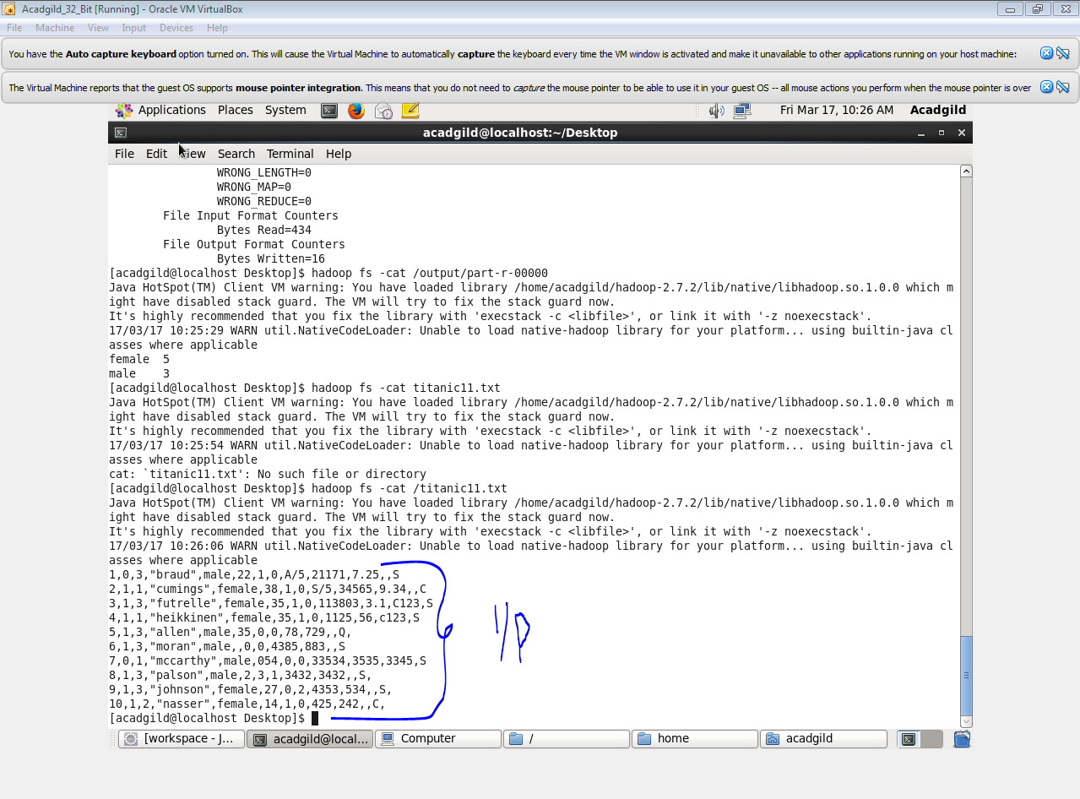

**CODE**

**DRIVER**

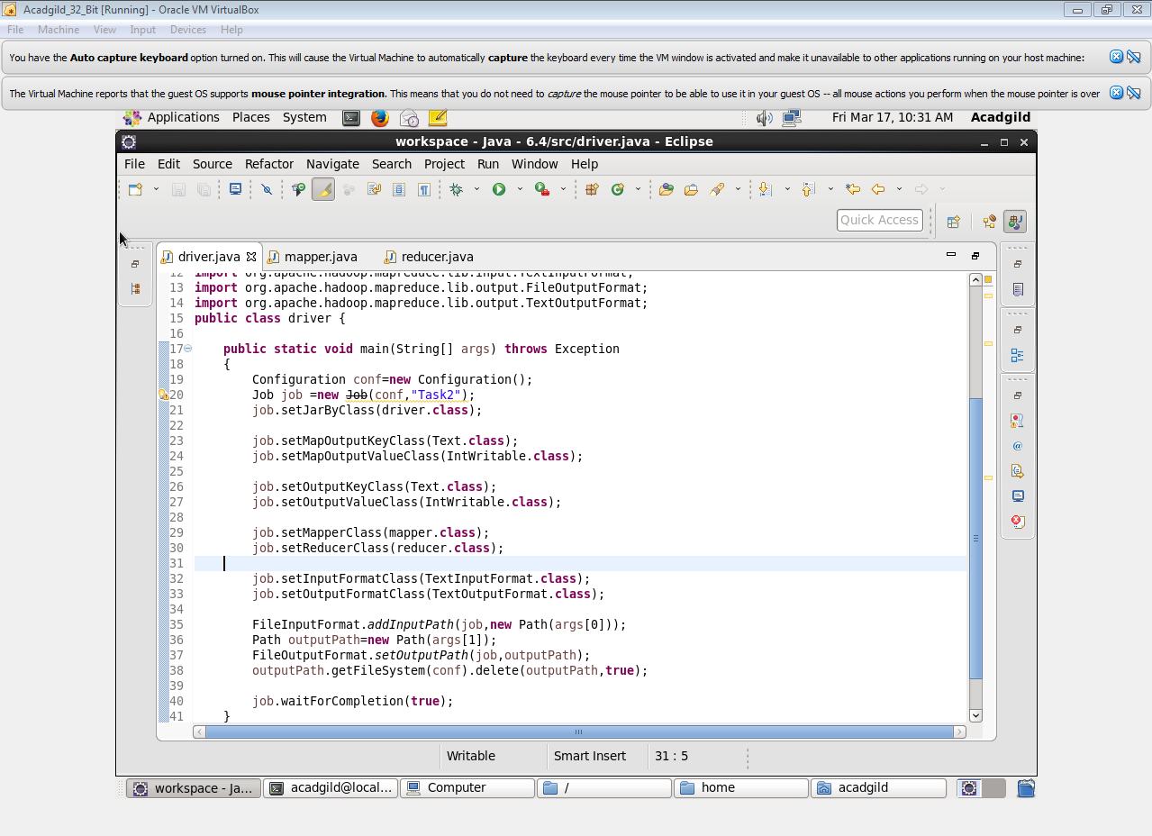

**MAPPER**

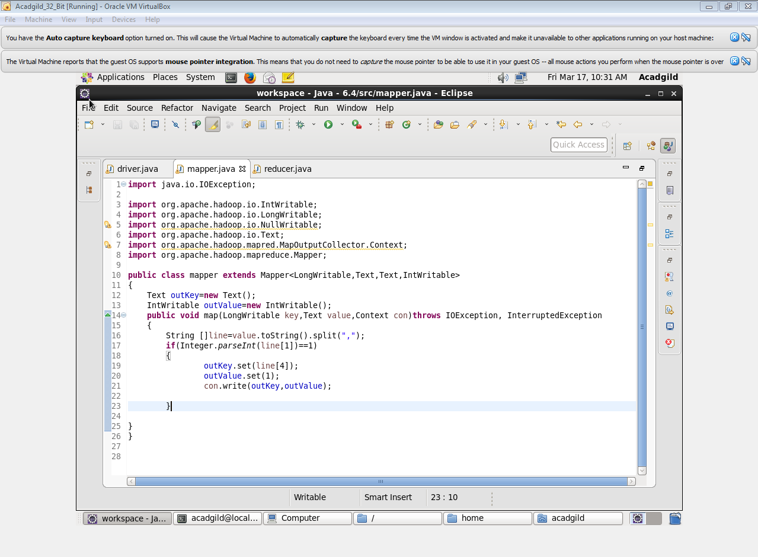

**REDUCER**

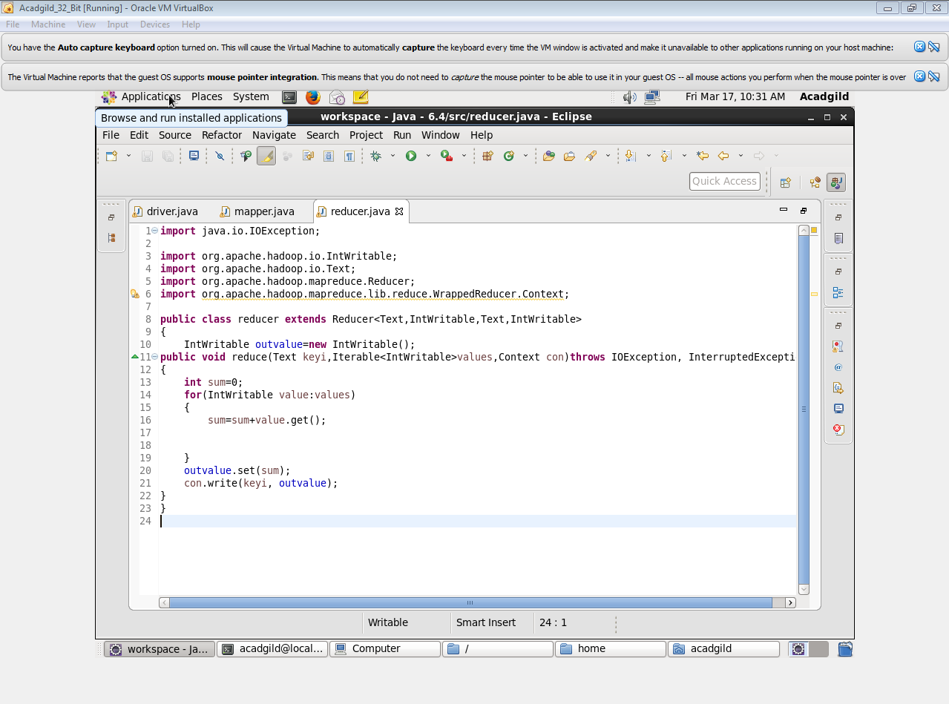

**OUTPUT**

